ASPAC EIA Seminar
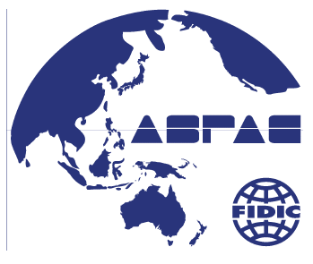
December 14, 2017
Role of Consulting Engineers
Announcement
It is a common understanding that every infrastructure facilities have to meet requirements of Environmental Impact Assessment which integrates accountability, stakeholder involvement, disclosure of information, social & environmental considerations throughout project life cycle.
ASPAC Capacity Building Committee conducted EIA fact-finding survey and collected answers from 10 member associations out of 21 member countries in September 2016. The survey revealed the fact that adequate institutional frameworks is lacking, consultants in charge of EIA face discrepancy between government policy and implementation in the field, lack of financial and human resources in many ASPAC countries. Based on the results of survey, ASPAC Executive Committee decided to hold EIA seminars in Jakarta and Hanoi to share common understandings and search for solutions.
Expert speakers from JICA, Indonesia, Vietnam and
Japan will present EIA practices, challenges and prospects to deepen understandings of EIA. As a practical tool, JICA’s Guidelines for Environmental and Social Considerations is introduced and case studies will be presented to show its effectiveness. As this Guideline is used for ODA loan and grant projects, those participants
interested in ODA projects may expedite business opportunity.
Objective of the seminars is to share common practice of EIA and to present a showcase such that it may assist and encourage professionals in government entities and consulting firms in charge of EIA.
We would like to take this opportunity to invite those who are interested in this seminar.

Date: Thursday 14th December, 2017
Seminar Venue: Press Club
12 Ly Dao Thanh Corner of 59A Ly Thai To, Hoan Kiem, Hanoi
Tel: (84-4)3934-0888 Fax: (84-4) 3934-0899
Registration: Free
Please fill-in attached form for registration
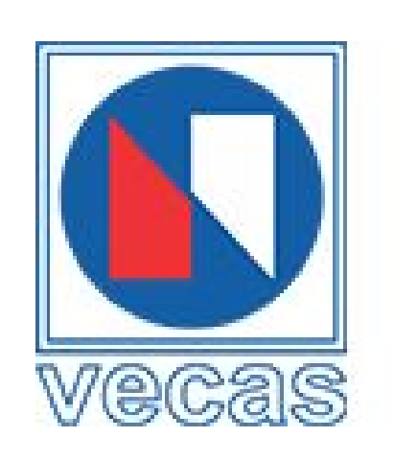
Ministry of the Environment
Institution of Professional
Engineers, Japan


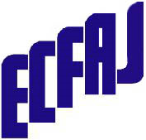
ASPAC EIA Seminar
Role of Consulting Engineers
December 14, 2017 13:00～17:40
Press Club, Hanoi

In support of
Supported by Ministry of the Environment, Japan (to be confirmed)
Cooperation with Japan International Cooperation Agency and
Institution of Professional Engineers, Japan
Program
12:30－13:00 | Registration
 | M.C. | Secretary General for FIDIC,  Engineering and Consulting Firms  Association, Japan (ECFAJ) | Yoshihiko Yamashita
13:00－13:05（5 min） | Opening Address
 | Speaker | President,  Vietnam Engineering Consultant Association (VECAS) | Nguyen Thi Duyen
13:05－14:05（60 min）  Q & A included | EIA Guideline
 | Speaker | Director,  Environmental and Social Considerations Supervision Division,Credit Risk Analysis and Environmental Review Department,  Japan International Cooperation Agency (JICA) | Dr.NoriakiMurase
14:05－15:05（60 min）  Q & A included | EIA Practice
 | Speaker | General Manager,  Environmental Science & Engineering Dept., Nippon Koei | Norihiko Inoue
15:05－16:05（60 min） | Refreshment
16:05－17:05（60 min）  Q & A included | EIA Practice
 | Speaker | Environmental Engineer,  Power Engineering & Consulting Company 3 - (PECC3) | Nguyen Thai Vu
17:05－17:35 (30 min) | Q & A
17:35-17:40 (5 min) | Closing Address
 | Speaker | Chair,  ASPAC Capacity Building Committee  Managing Director,  Nippon Suido Consultants | Dr. Toshio Kurashige

Registration Form
ASPAC EIA Seminar
Role of Consulting Engineers

Deadline: December, 2017

Date: Thursday 14thDecember, 2017
Venue: PressClub
12 Ly Dao Thanh Corner of 59A Ly Thai To, Hoan Kiem, Hanoi
Tel: +84 24 3934 0888 Fax: +84 4 3934 0899

Name
Title
Affiliation
Tel & Fax
E-mail

Please send registration Form to
Vietnam Engineering Consultant Association (VECAS)
6th Floor, Intellectual Palace, No. 1 Ton That Thuyet St., Cau GiayDist, Hanoi
Tel: 84.24.38218093 Fax: 84.24.39740109 E-mail: vecas95@gmail.com
Contact person: Mr. Nguyen Kim Nhu

